Minutes of the Strategic Planning Committee
Thursday, October 14, 2021
8:00 a.m. to 9:30 a.m.
Cougar Room

Present: Vicki Jacobi, Xiaohong Li, Damon Bell, Sharyn Eveland, Amanda Bauer, Faith Angeles, Amar Abbott, Leslie Minor
Absent: Paul Blake, Tina Mendoza, Rafael Andrade Guest: Deb Daniels
Secretary: Brandy Young

Review the Minutes from September 23, 2021
The minutes were approved with no corrections.

Planning Guide
The Planning Guide was reviewed and approved with the following updates:
- Update the headers with the current year
- Add review date to end of document
- Update the Strategic Action Plan page with the current year
- Create a table with “at a glance” due dates for all plans; add to the end of the guide

White Board Exercise: Framework for Comprehensive Program Review (CPR)
A framework for brainstorming ideas was used to begin the process of developing the new CPR. This exercise will be a continuous agenda item. The framework outline:

WHY?
- Set objectives/goals
- Establish incentives
- What is the purpose?
Whiteboard entries and discussion:
- Title 5
- ACCJC Standards
- Quality assurance – Best interest of students
- Review trends/umbrella of APR
- Consistency/stability
- Longitudinal view
- Educational Master Plan structure
- Continuous improvement
HOW?
- Set timelines?
- By Division/program or By Instructional, Student Services, and Administrative programs?
- How often do we do this?
  - 5 year cycle for selected programs? During ‘off’ year, the rest of programs submit an annual update?
Whiteboard entries and discussion:
- Structure
- Categorize programs/divisions/meta majors
- Rotating schedule of CPR cycle
- Drilled down data (i.e., Library - # of students vs. what students do)
- Schedule programs into tracks by year
- CPR = large report on track year
- Annual update = simple, small report on off years
- CPR can be a challenge due to the length of time being reviewed; turn over in staff and faculty, lost information over time
- What is the difference between an “Annual update” and the current APR process we have now?
WHAT?
- Set criteria
- What are we reviewing?
- What are we measuring? … and Why?
- Is it meaningful?
- What will we do with these reviews?
Whiteboard entries and discussion:
- Data trends
- Look back to look forward
- Disaggregated data from the SAP
- How many programs align to measures of SAP
- Format of data
The process of CPR: Not yet discussed

- Step 1. Planning?
- Step 2. Data review?
- Step 3. Personnel and Resource request?
Things we will need: Not yet discussed
- How to Guide
- Providing CPR Template?
- Examples
- Task Force? (SPC members?)

Whiteboard photos next page.
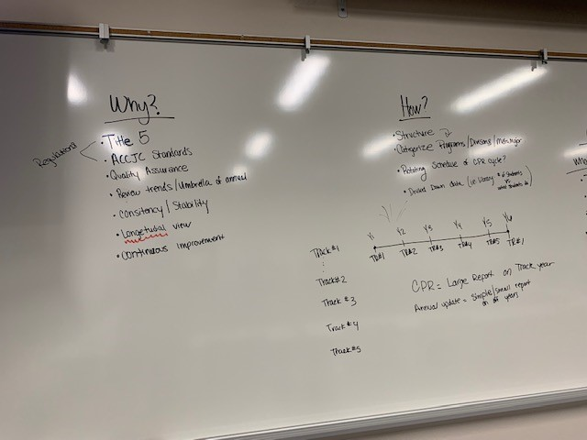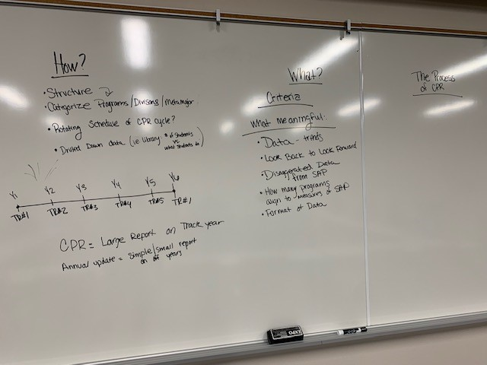

The next meeting is scheduled for November 11, 2021 at 8:00 a.m. in the Cougar Room.
Respectfully submitted by Brandy Young

