

West Kern Community College District-
Taft Union High School District

Dual & Concurrent
Enrollment Program
Instructor Handbook
2017-2018
Table of Contents
Quick Contact Reference 1
Instructional Responsibilities 3
Hiring and Compensation 4
Procedure for Reporting Instructor Absences 5
Dual Enrollment Instructor: Grade and Deadlines 8
Instructor Quick Reference – Cougar Tracks 10
Frequently Asked Questions 12
FERPA FAQ’S for Faculty 13



Quick Contact Reference
Primary Contact:
Kristi Richards, Career Transitions Facilitator-Counselor
krichards@taftcollege.edu
(661) 763-7813

Dual/Concurrent Enrollment Counseling
TC CTE Program Requirements
Dual Enrollment Advisory Committee Meeting Dates
Dual/Concurrent Enrollment General Information
Questions about Special Admit Form
Calendar (Deadlines, Grades)
Liaison for Student Services (Grades, Assessment, etc.)
Outreach/Recruitment

Tony Cordova, Career Technical Education (CTE) Director
acordova@taftcollege.edu
(661) 763-7814

Instructor Handbook
New Dual Enrollment opportunities

Sandra Mittelsteadt, Administrator of Career and Technical Education
smittelsteadt@taftunion.org

(661) 763-2366
TUHS CTEC Questions

Tammy Sutherland, TUHS Guidance Counselor
tsutherland@taftunion.org
(661) 763-2325
High School Schedule Changes
High School Grades
Dual Enrollment Coordinator

Taft College Admissions
(661) 763-7741
Questions related to application, orientation

Cougar Tracks PIN reset
Special Admit

Taft College Academic Records
(661) 763-7756
Taft College grades/transcripts
Certificate application status

Instructional Responsibilities
- You will be provided a customizable syllabus for your Dual Enrollment course. At the beginning of each semester, prepare and distribute current course syllabi to the students in each class taught. Such syllabi shall be consistent with approved course of study outline (or online at http://www.taftcollege.edu/faculty-and-staff/faculty-resources/) and should include, as applicable, an outline of course objectives and requirements (exams, assignments, written work, field trips, etc.), grading policy, course content, student learning outcomes, and any specific rules or expectations of the instructor.
- Present course content according to a planned schedule and consistent with approved course outline.
- Begin and end scheduled classes on time.
- Instruct and/or supervise students during all class times.
- If ill, it is the responsibility of the instructor to contact the proper personnel.
- Establish and consistently enforce appropriate classroom rules and procedures.
- Administer exams or other assessment tools consistent with course objectives.
- Return student graded materials, with appropriate feedback, in a timely manner.
- Maintain accurate records of students' grades.
- Assess and report Student Learning Outcomes.
- Submit records of grades, student attendance, textbook orders and other required reports to designated campus officials in a timely manner.
- As a Dual Enrollment Instructor, you must also follow and implement the following policies and procedures designated by the Board and Administration of Taft College. These policies and procedures may also be found in the appendix of this handbook for your convenience or online.

Hiring and Compensation
High School Instructors
In order to be hired on as an Instructor and receive compensation, you must comply with these steps:
- You must be fingerprinted and show proof of a valid TB test (performed within the past 2 years).Present course content according to a planned schedule and consistent with approved course outline.
- Complete the Taft College personnel application form and submit it as well as your transcripts to the Taft College Human Resources Office. You can find the application on the website.

*Please contact Human Resources or Office of Instruction for specific disciplines
*These listed requirements are subject to change. Please consult with the Human Resources office for any new course minimum qualifications.

Procedure for Reporting Instructor Absences
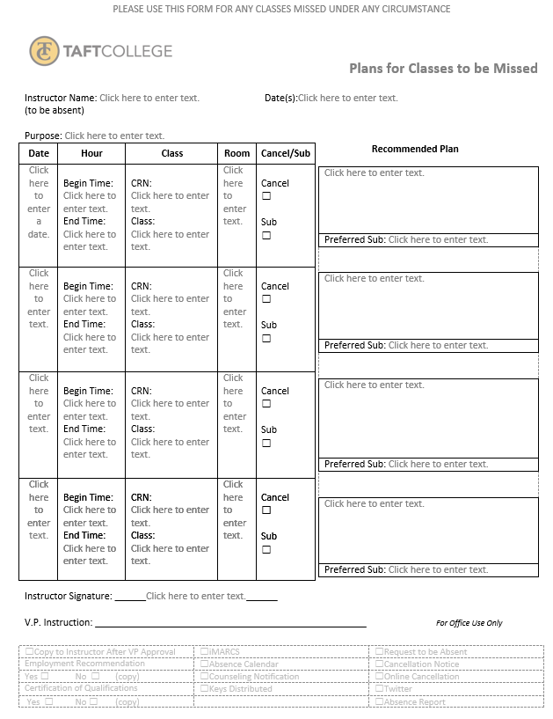
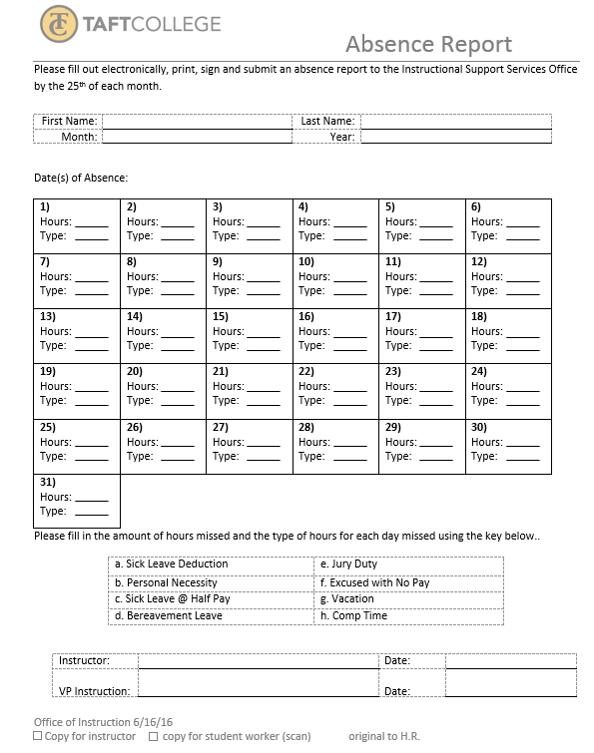

Dual Enrollment Instructor: Grade and Deadlines
Grading
Forms, policies, and directions on how to post grades are available on the Faculty Resource page, which can be accessed directly at: http://www.taftcollege.edu/faculty-and-staff/faculty-resources/
How do I drop a student after the Census date?
For a full‐term course, students can be dropped via Cougar Tracks on the Faculty Initiated Drop link. You will have one (1) day to drop students before the final W date. After this date, a grade must assigned to the student.
Can I drop a student after the drop with W deadline?
No – students must drop themselves or be dropped by the instructor prior to the final drop with W deadline. After that, the student must receive a final letter grade, of which a W will not be an option. The student may appeal for a W based on documented extenuating circumstances.
How early can I start entering grades?
Faculty can start entering grades for full‐term courses beginning the Friday before finals week.. Short course/Positive Attendance hours can be entered beginning the last day of class and are due within five (5) working days after the last class. Grades can be repeatedly submitted (saved) until the final grade deadline posted for each term.
How do I change a grade after it’s been posted?
Grades can be repeatedly submitted (saved) until the final grade deadline posted for each term. Once the deadline has passed, faculty must submit a paper Change of Grade form available at the following link http://www.taftcollege.edu/wp-content/uploads/2016/06/Change-of-Grade-Report-1.pdf

Submitting Grades via Cougar Tracks
Banner Self-Service is a web service that allows Taft College students and employees to view and edit information in Banner specific to the individual. Faculty Services is part of Banner Self-Service that allows faculty to access rosters, post grades and much more.
Banner’s Post Grades supports Pass (P), No Pass (NP), and Incomplete (I). The “Attend Hours” field can be recorded for “positive attendance” courses, and Last Attend Date (if the instructor knows it) should be entered for those students who have withdrawn from the class. Grades can be repeatedly submitted (saved) until the closing date issued from Admissions and Records.

Instructor Quick Reference – Cougar Tracks
Technical Problems
- If you’re encountering problems logging into your Cougar Tracks, please call our Admissions Office at 763-7741.

Class Rosters
Display Class Rosters Onscreen
- Log into Cougar Tracks https://ct-prod-ssb.taftcollege.edu:9021/ctprod/twbkwbis.P_WWWLoginTaft
- Click the Faculty Services tab.
- Click the Rosters link.
- Select the desired term and click the Submit button.
- Select the checkbox (es) for the desired class(es) and click the Create Roster(s) button. The selected roster(s) will appear
Download Class Roster
- If necessary, display class roster.
- Click the Excel Download button. The roster will appear in printable format on the screen.
- Click the Save button.
- Select where to save, name the roster and click save.

Print Class Roster & Add Codes
- If necessary, display class roster.
- Click the Print Basic Roster button. The roster will appear in printable format on the screen.
- Depending on the browser, do one of the following:
Internet Explorer | Firefox
Select File > Print Preview | Right-click (Mac-users; Command-click) on the document.
Click the dropdown arrow to the right of “As laid out on the screen”. | Select This frame > Print Frame…
Chose “Only the selected frame”. | Click OK.
Click the Print… button.
Click the Print button.

Frequently Asked Questions
Who do I call if I have questions or a problem with a Dual Enrollment class?
- If you have a question or problem with a class, please contact Kristi Richards. She can be reached by email at krichards@taftcollege.edu or by phone at (661) 763-7813.
Where should I direct students if they have questions?
- If students have any concerns/questions about their dual enrollment status, need additional forms, etc., please contact the Career Transitions Facilitator-Counselor, Kristi Richards, at (661) 763-7813 or via email at krichards@taftcollege.edu
Will I be evaluated?
- West Kern Community College District (Taft College) has primary right to control and direct instructional activities. You must teach in a manner consistent with the approved outline of record as well as collegiate rigor. Therefore, the program will be evaluated for content and rigor.

FERPA FAQ’S for Faculty
What is FERPA?
The Family Educational Rights and Privacy Act (FERPA) (20 U.S.C. § 1232g; 34 CFR Part 99) is a Federal law that protects the privacy of student education records. The law applies to all schools that receive funds under an applicable program of the U.S. Department of Education. When a student is 18 or attends a school beyond the high school level, the rights to a student’s educational record transfer from the parent to the student, regardless of age.
What does FERPA govern?
Access and release of information of the student’s educational records.
What does FERPA require for colleges to be in compliance?
- Notify students annually of their rights;
- Protect students’ rights to inspect and review their education records;
- Protect students’ rights to request to amend their education records;
- Protect students’ rights to limit disclosure of personally identifiable information contained in education records;
- Ensure that third parties do not disclose personally identifiable information;
- Keep records of requests and disclosures of student education records.

Who has FERPA rights at the postsecondary level?
All currently enrolled students, regardless of the age, including continuing education students, students auditing a class, and distance education students; and former students.
Who may access personally identifiable information without the student’s consent?
Generally, schools must have written permission from the parent or eligible student in order to release any information from a student's education record. However, FERPA allows schools to disclose those records, without consent, to the following parties or under the following conditions:
- School officials with legitimate educational interest;
- Other schools to which a student is transferring;
- Specified officials for audit or evaluation purposes;
- Appropriate parties in connection with financial aid to a student;
- Organizations conducting certain studies for or on behalf of the school;
- Accrediting organizations;
- To comply with a judicial order or lawfully issued subpoena;
- Appropriate officials in cases of health and safety emergencies; and
- State and local authorities, within a juvenile justice system, pursuant to specific State law.

Who handles off‐campus inquiries, including inquiries from parents?
The Records Office provides official verification of student educational information including general requests and all requests made by subpoena. Law enforcement inquiries should be directed to the Campus Police Office or to the Office of the Vice President of Student Services.
What is Directory Information?
Schools may disclose, without consent, “Directory” information defined as, “information contained in an education record of a student which would not generally be considered harmful or an invasion of privacy if disclosed.” Personal identifiers, such as student ID numbers or social security numbers, race/ethnicity, gender, religious preference, grades and GPA can never be designated as directory information.
Taft College has identified the following elements as directory information:
• Name • Dates of Attendance
• Field of Study • Level of Enrollment (# of credits as full‐time/part‐time)
• Degrees and Certificates Earned • Participation in officially recognized activities/sports

What is a Directory Hold?
Students may request that Directory Information may not be released to outside parties without their consent when they apply online to Taft or come in‐person to the Admissions Office. A “confidential” flag will appear in the student’s records in the Banner system. Directory information may not be given out for students who have the Directory Hold in place. Do not release any additional information beyond directory information to any party beyond Taft College staff and faculty without written consent of the student.
How do faculty provide students’ grades under FERPA?
- The posting of grades either by the student’s name, institutional student identification number, or social security number without the student’s written permission is a violation of FERPA. This includes the posting of grades to a class/institutional web site and applies to any public posting of grades for students taking distance education courses. Even with names obscured, numeric student identifiers are considered personally identifiable information. Therefore, the practice of posting grades by social security number, a portion of it, or student identification number violates FERPA.
- Instructors and others who post grades must use a system that ensures FERPA requirements are met. This can be accomplished either by obtaining the student’s uncoerced written permission to do so or by using code words or randomly assigned numbers that only the instructor and individual student know. The order of posting may not be alphabetical.
- The best method for students to obtain their grades is through Taft College’s secured student information system, Cougar Tracks, where faculty electronically posts their grades and students view their grades via a secure network ID and password.
- Grades are available in Cougar Tracks the Monday after the end of the term.

Does FERPA affect E‐mail Communication?
Faculty must protect their students’ contact information at all times. E‐mail distribution lists must be created carefully so that the e‐mail addresses are not revealed. This can be accomplished by placing email addresses in the “blind copy” (Bcc) field.
Does FERPA impact course web sites?
Distance education and the use of web sites to support courses taught through distance education are held to the same FERPA standards. Only Directory information may be available on a public web site. A student’s “block” of directory information must be recognized and their information may not be included.
What about printed documents?
Documents, such as rosters and sign‐in sheets, which have the student’s Taft College ID number or other personal information, should not be left out for others to see. It is important to destroy or shred documents containing students’ personal information that are no longer needed.



Taft College
29 Cougar Court
Taft, CA 93268
(661) 763-7700

